WEEK5 PLAYWRIGHT TEST REPORT AND DEMO
GATE 5

Purpose of the document : This report focuses on the reporting part and the demonstration part of the test is created and how we make it more stable.

Prepared By : MUHAMMED ALI M A
DATED BY : 4 JULY 2026
ASSIGNMENT : GATE 5

OBJECTIVE
As per the assessment question create test cases for each scenarios and solve the errors/ issues mentioned in the scenario and show the evidences on how you resolve it.
Scenario 1: Login fails (1 in 10) - Click before hydration - Web-first expect gate - 50x green + trace
Scenario 2: Cart total off by a paisa - Float tax math - Integer paise + invariant - Amount asserted exact
Scenario 3: Sync test hangs on WebKit - Offline set before load - Load first, then offline - Cross-browser green
Scenario 4: Refund posts twice - No idempotency key - Idempotency-Key + ledger - refundCount === 1

Environment and Setup
- Language used - TypeScript
- Technology Used – Playwright
- OS/Browser – Windows / Chrome/webkit
To setup the code:
Run this command
git clone –branch muhammed-week5-gate5 --single-branch https://github.com/ust-sdet-training/SDET
or
clone the repo : https://github.com/ust-sdet-training/SDET
go to the branch: muhammed-week5-gate5

after cloning
go to the directory /playwrightweek5 or run the command cd /playwrightweek5

then run the command
npm isntall
in order to download the dependencies

URL Configuration:
baseURL: process.env.BASE_URL || 'http://localhost:5173',
apiURL: process.env.POS_API_URL || 'http://localhost:4000';
why hard coded : since this is used for assessment ,current test haven’t considered all the environment edgecases.
Project Structure: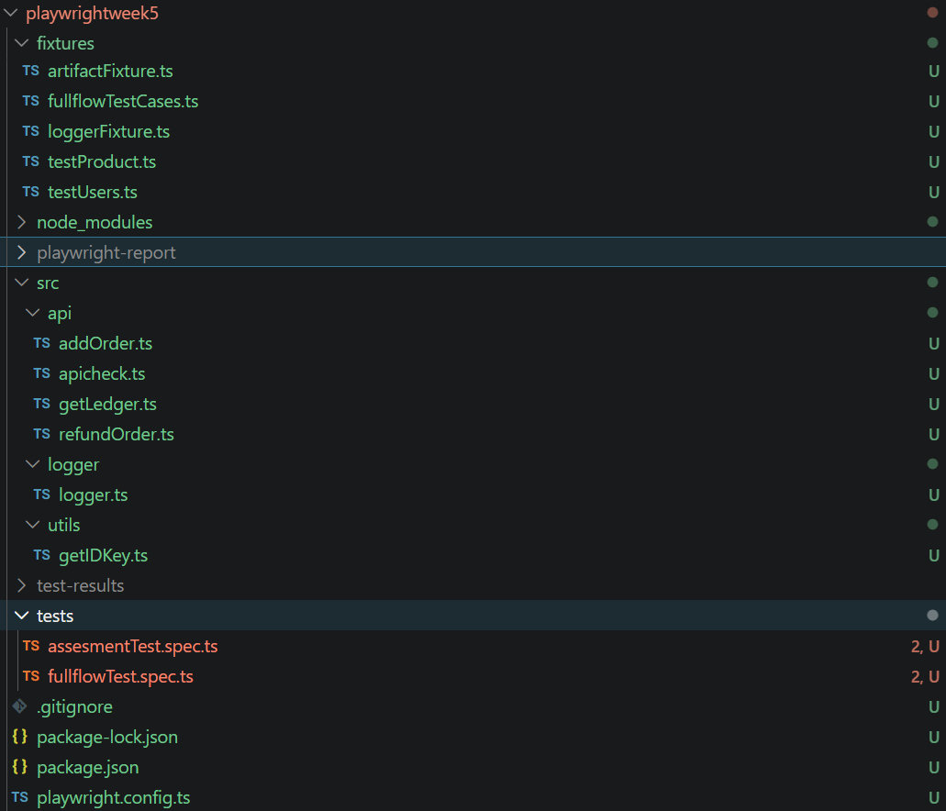
Test and Scenarios :
Scenario 1: Login fails (1 in 10) - Click before hydration - Web-first expect gate - 50x green + trace 1
Initial error result: Test failed when I run the test with repeat-each=50 , 8 Failed and 42 passed
Initial finding: Test failed because click button was not visible to click
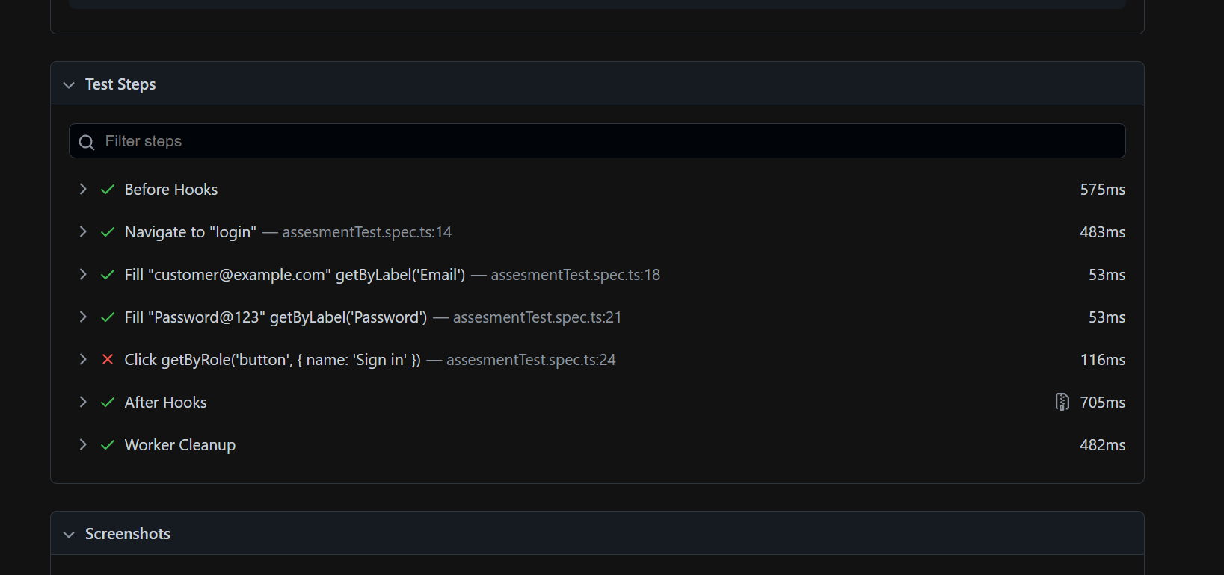
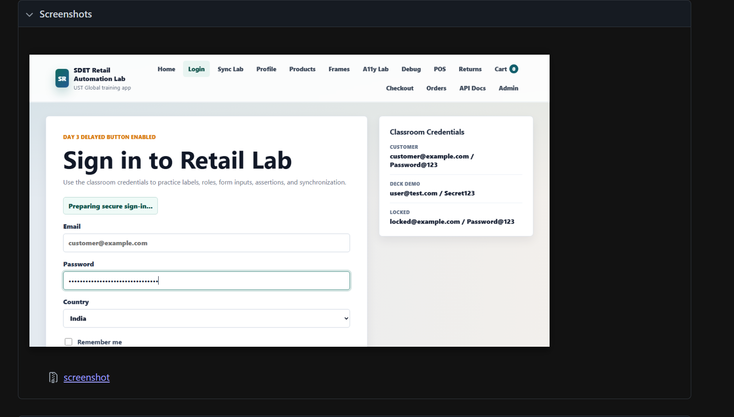
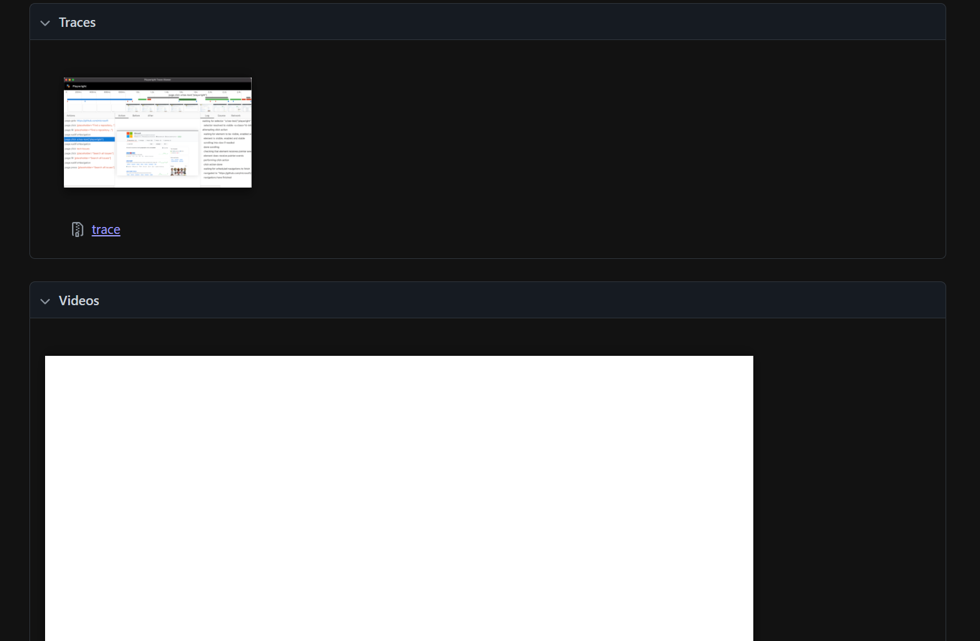
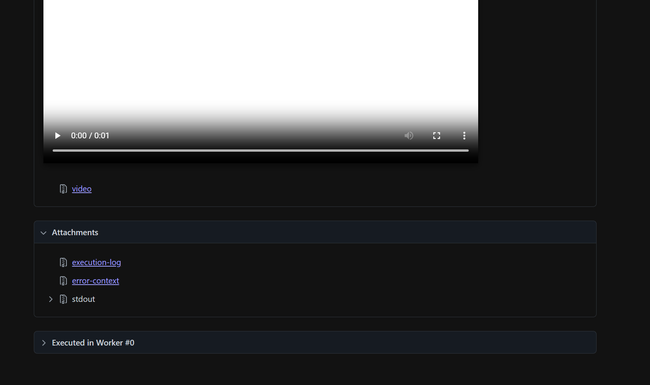

Solution: Use proper await in the click button
Corrected code:
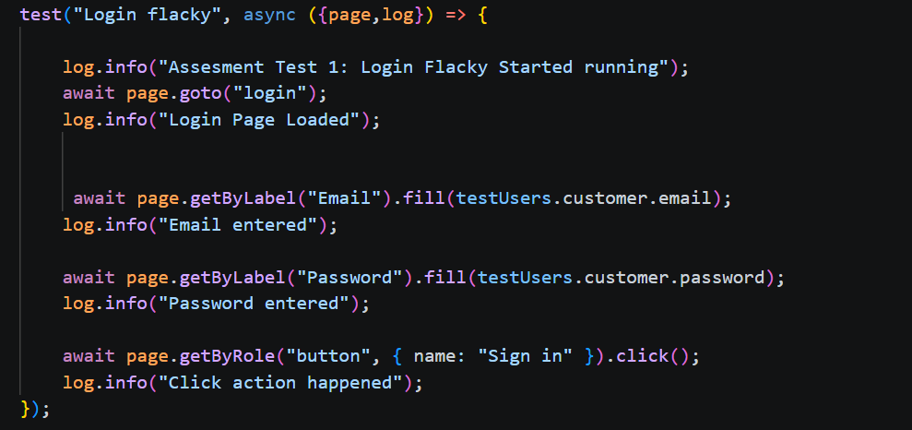
Result: the code run successfully
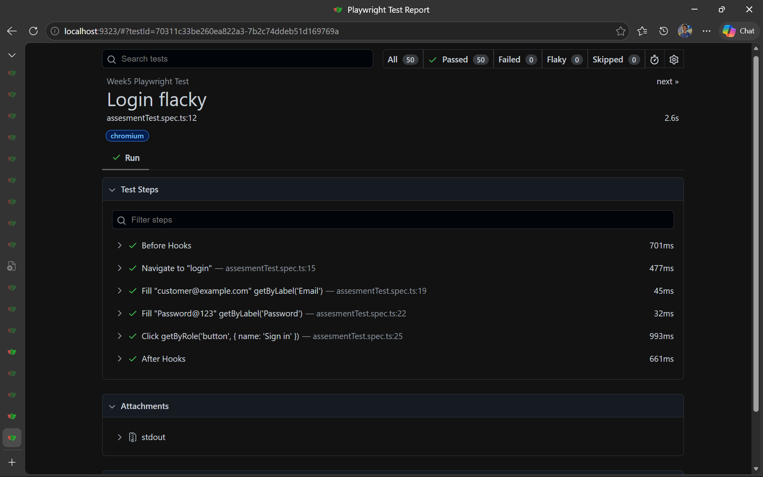
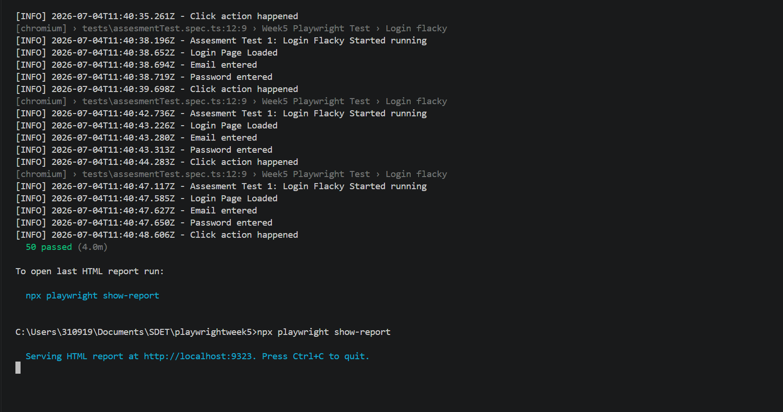
The code run successfully

Scenario 2: Scenario 2: Cart total off by a paisa - Float tax math - Integer paise + invariant - Amount asserted exact
Initial error result: Test failed when I run the test
Initial finding: Test failed because the tax division is not matching to our api response
Solution: Use Integer only
Corrected code:
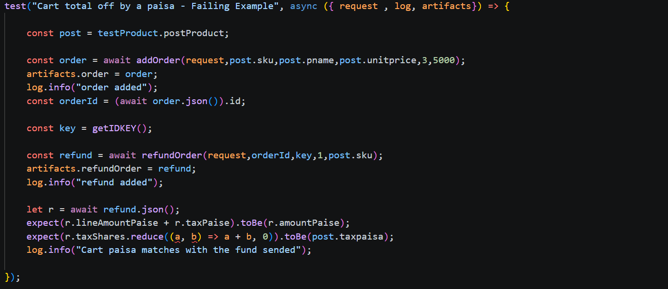
Result: the code run successfully
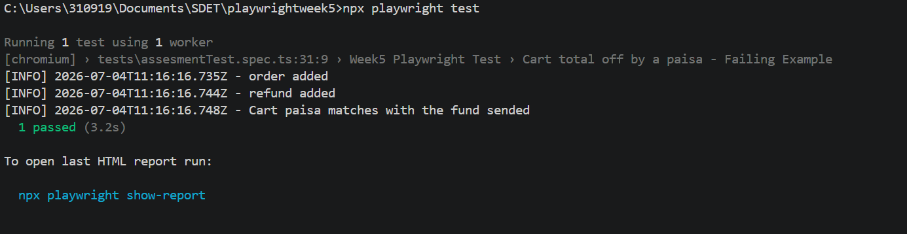
The code run successfully

Scenario 3: Sync test hangs on WebKit - Offline set before load - Load first, then offline - Cross-browser green
Initial error result: Test failed when I run the test
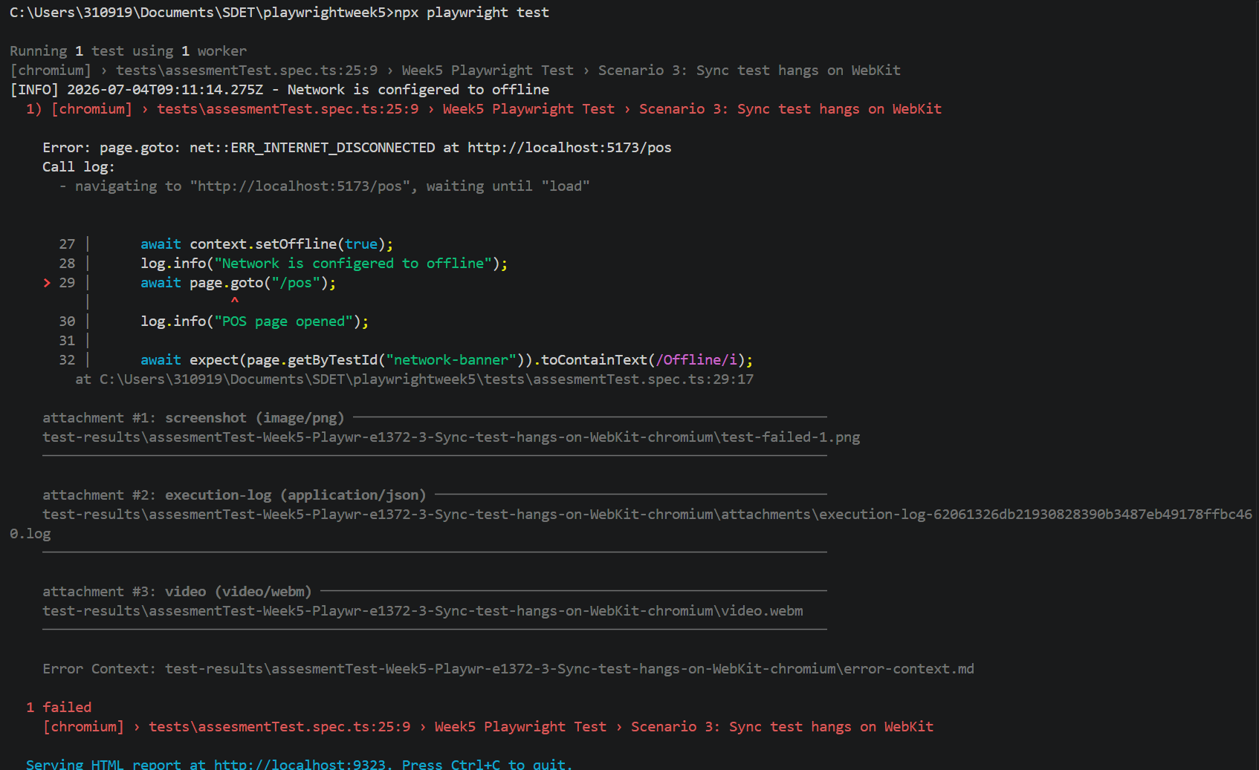
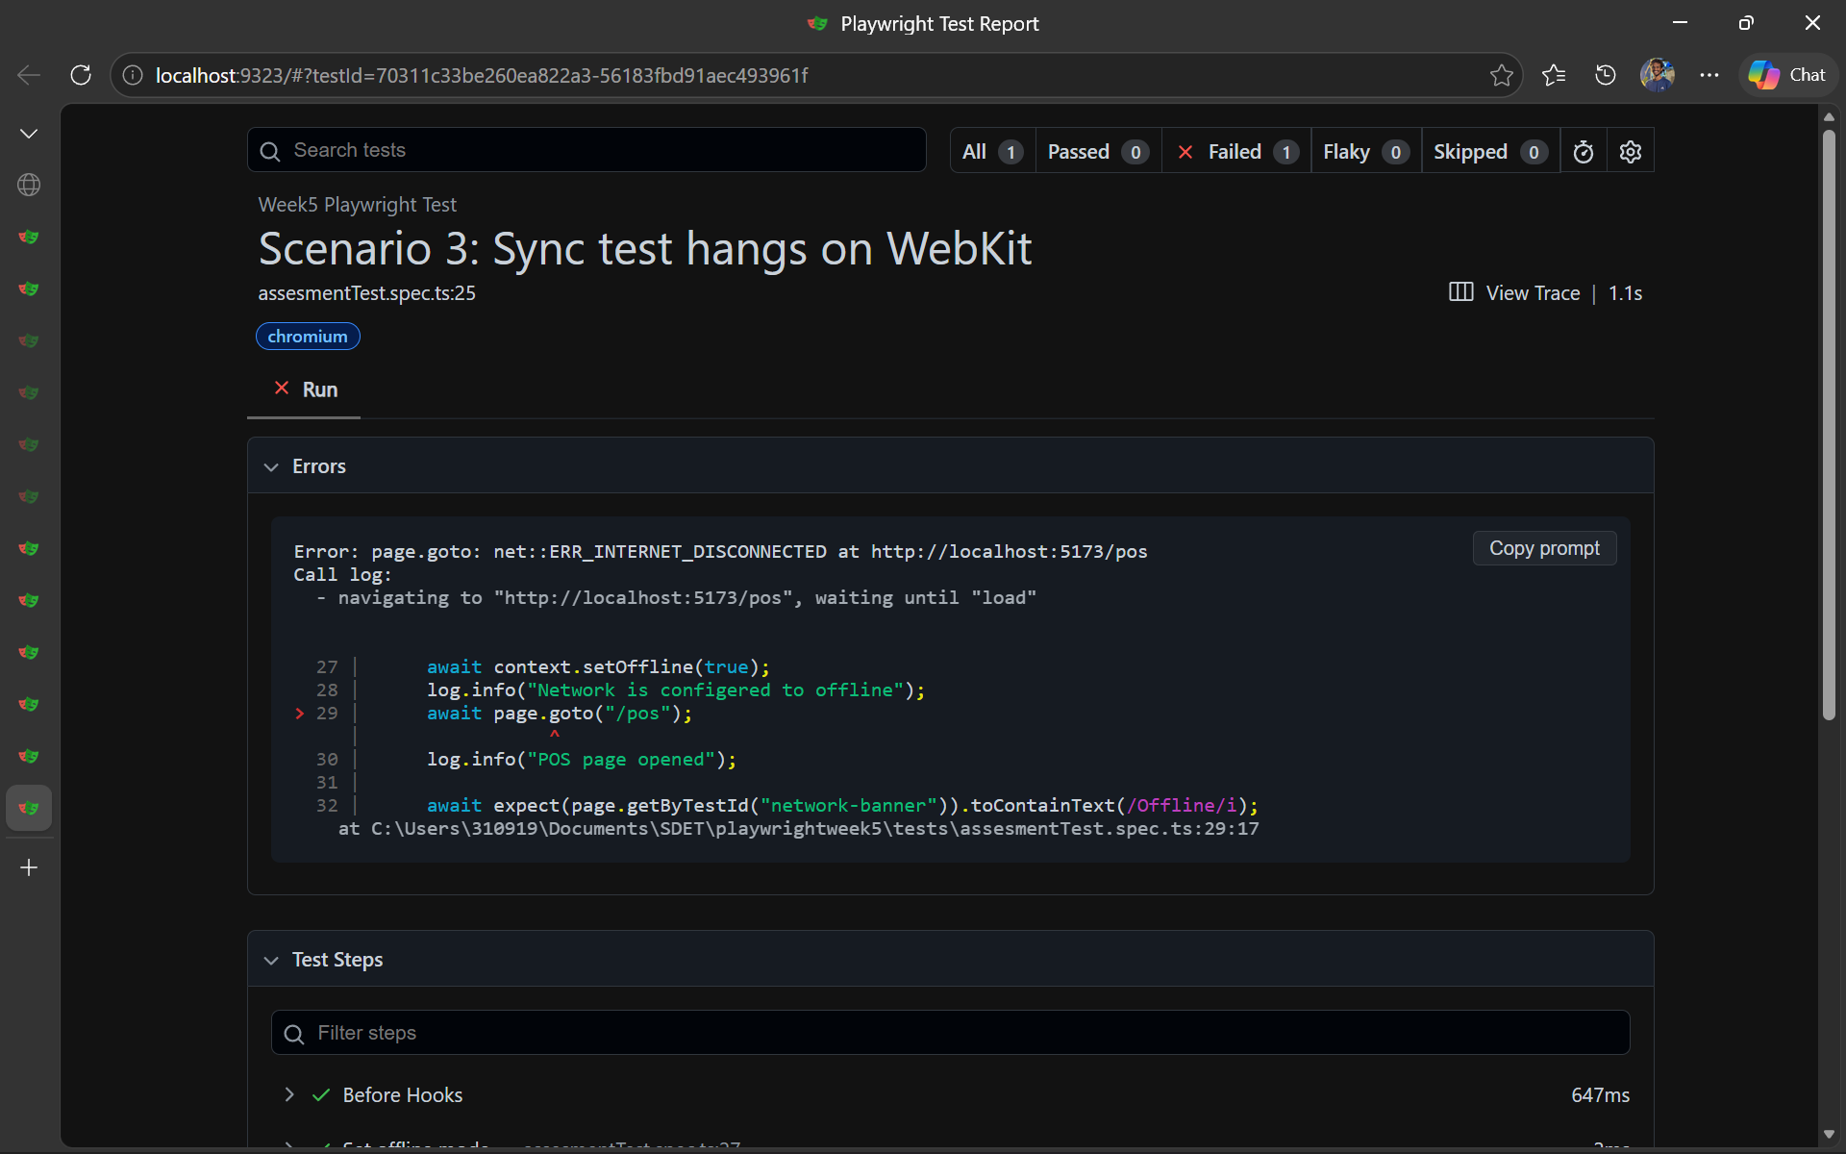
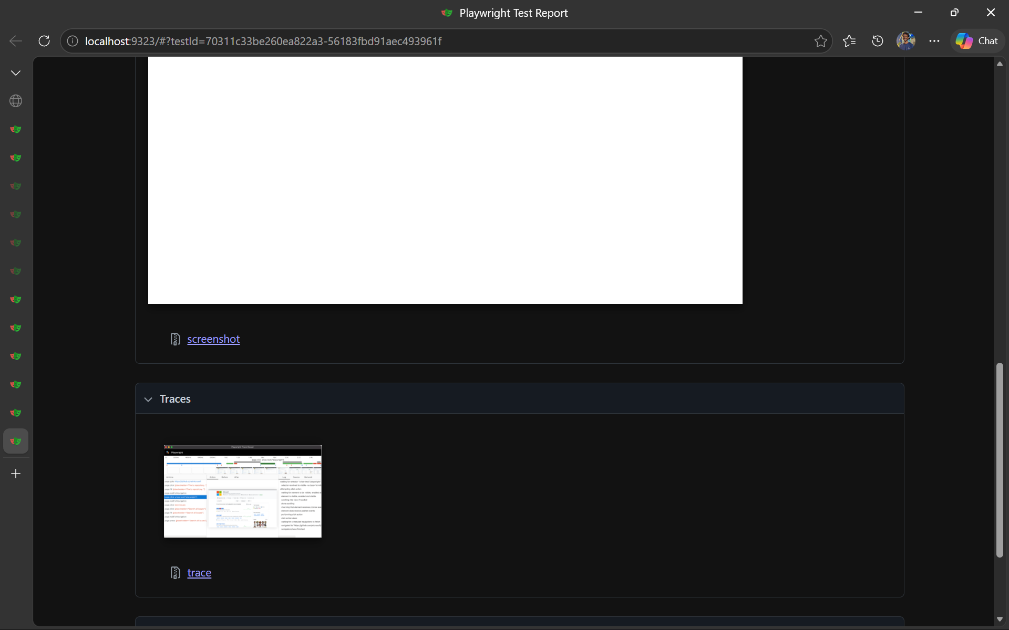
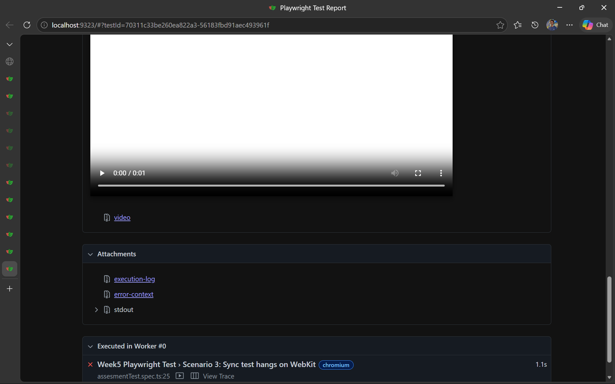
initial finding: Test failed and shows network error issue
Solution: Load the page before the offline is set
Corrected code:
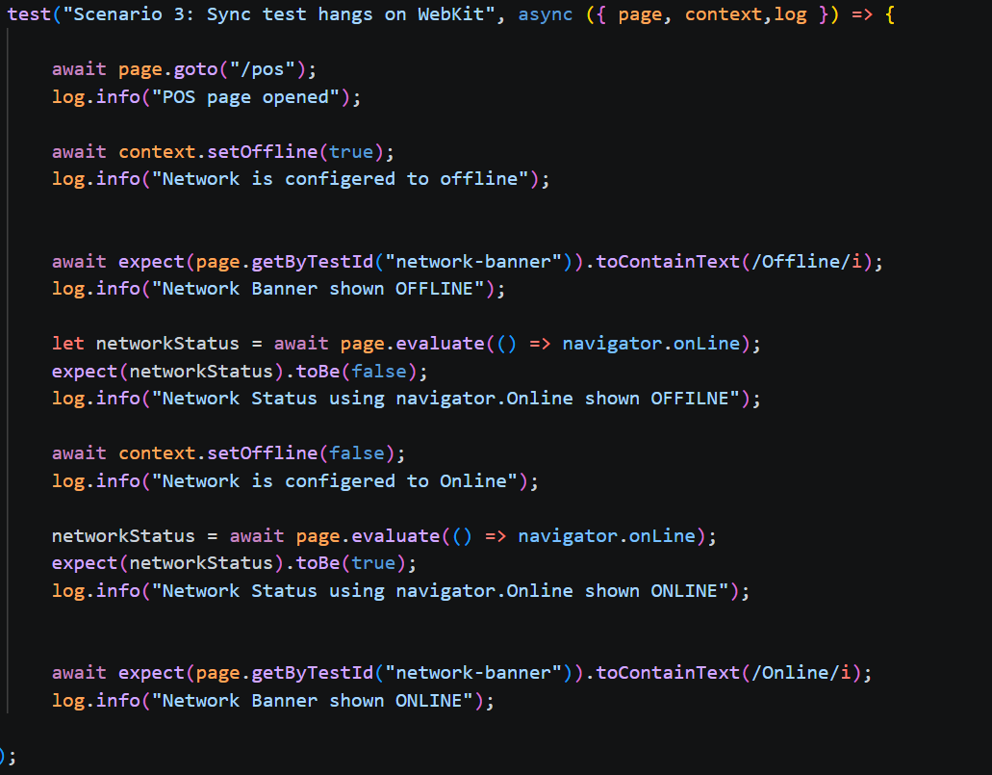
Result: the code run successfully
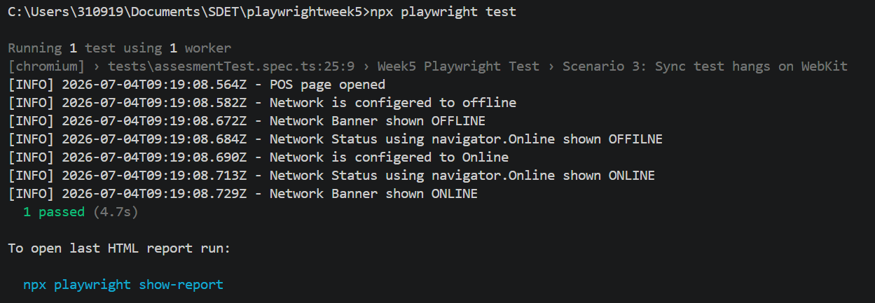
The code run successfully

Scenario 4: Refund posts twice - No idempotency key - Idempotency-Key + ledger - refundCount === 1
Initial error result: Test failed when I run the test , return is triggered two times
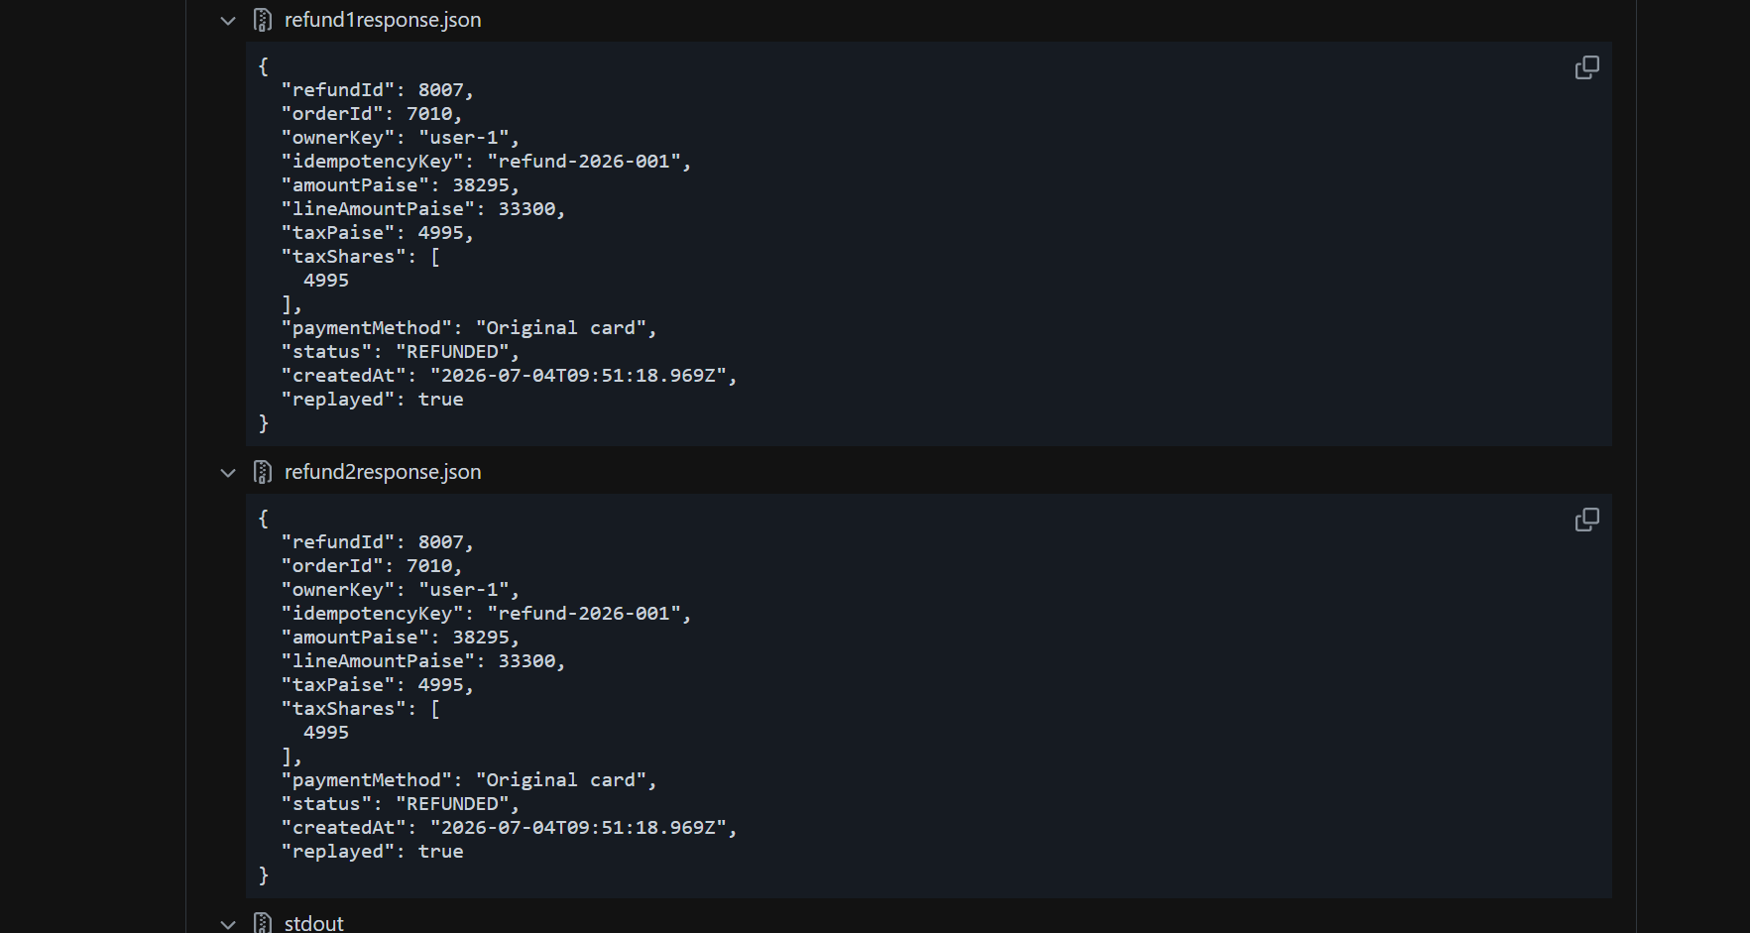
initial finding: Test failed and shows expected status code is 201 instead of 200 for the second refund and Ledger give refund count as 2
Solution: Introduced Idempotent Key and getLedger,
Corrected code:
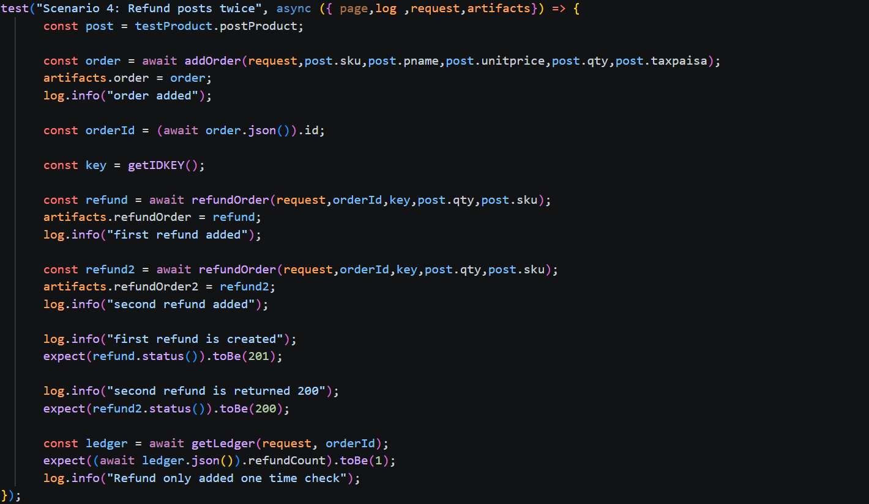
Result: the code run successfully
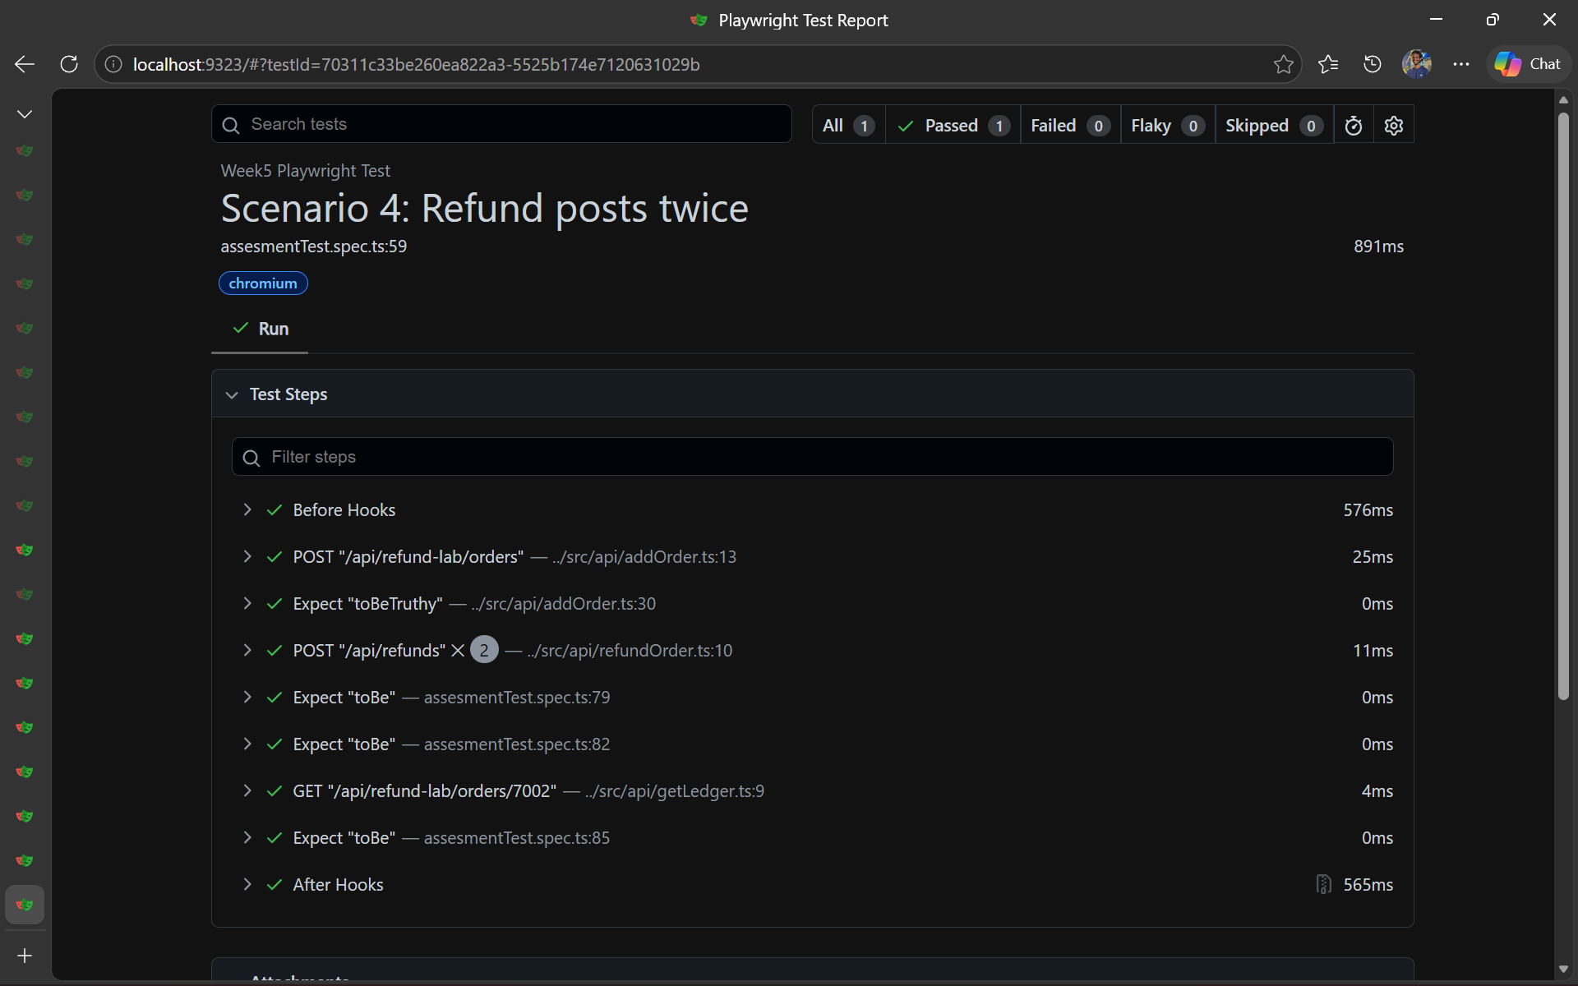
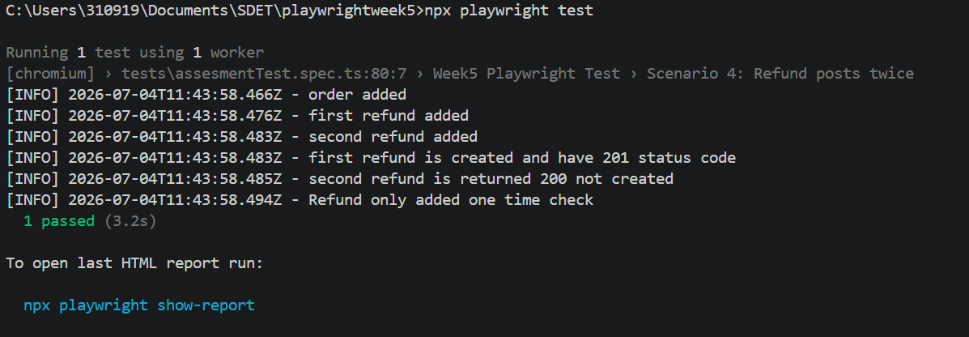
The code run successfully

Test Covered:
TC_ASS5_001 : Scenario 1: Login fails (1 in 10) = Passed
TC_ASS5_002 : Scenario 2: Cart total off by a paisa = Passed
TC_ASS5_003 : Scenario 3: Sync test hangs on WebKit = Passed
TC_ASS5_004: Scenario 4: Refund posts twice = Passed
TC_ASS5_005: Full FLow = Passed

Evidences:
When run : npx playwright test
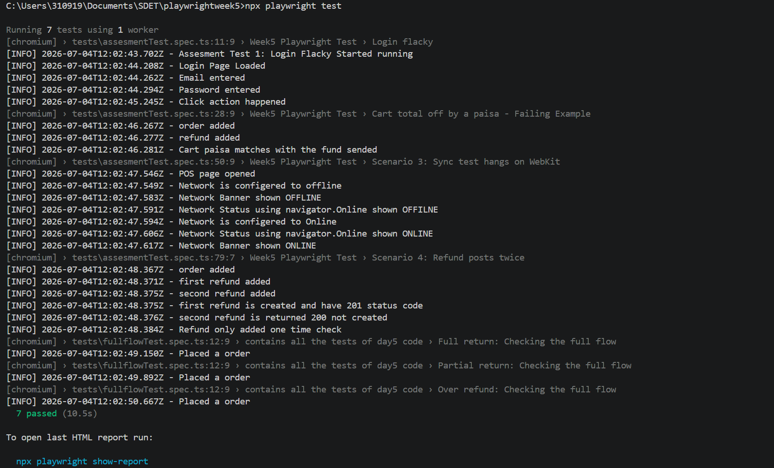
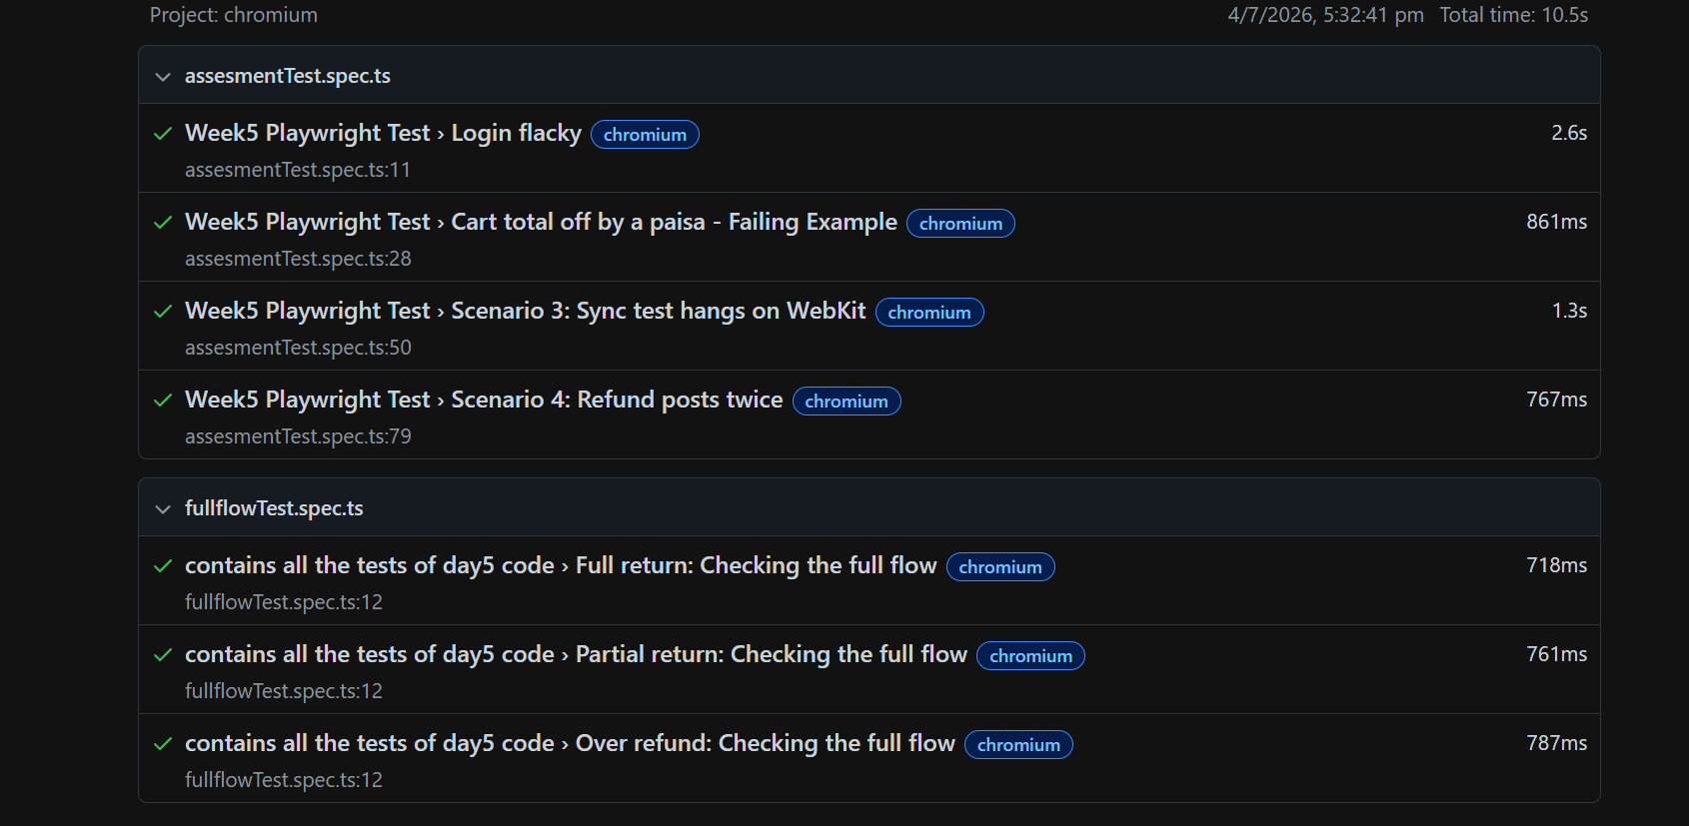

How to run:

Install dependencies
npm install
npm install playwright

Run full test
npx playwright test

Run full test with manually adding Base Url
BASE_URL=http://localhost:5173 npx playwright test

Run full test in headed mode (Visible)
npx playwright test --headed

Run a single test by passing the test file path
npx playwright test tests/login.spec.ts

To show the report
npx playwright show-report

Config:
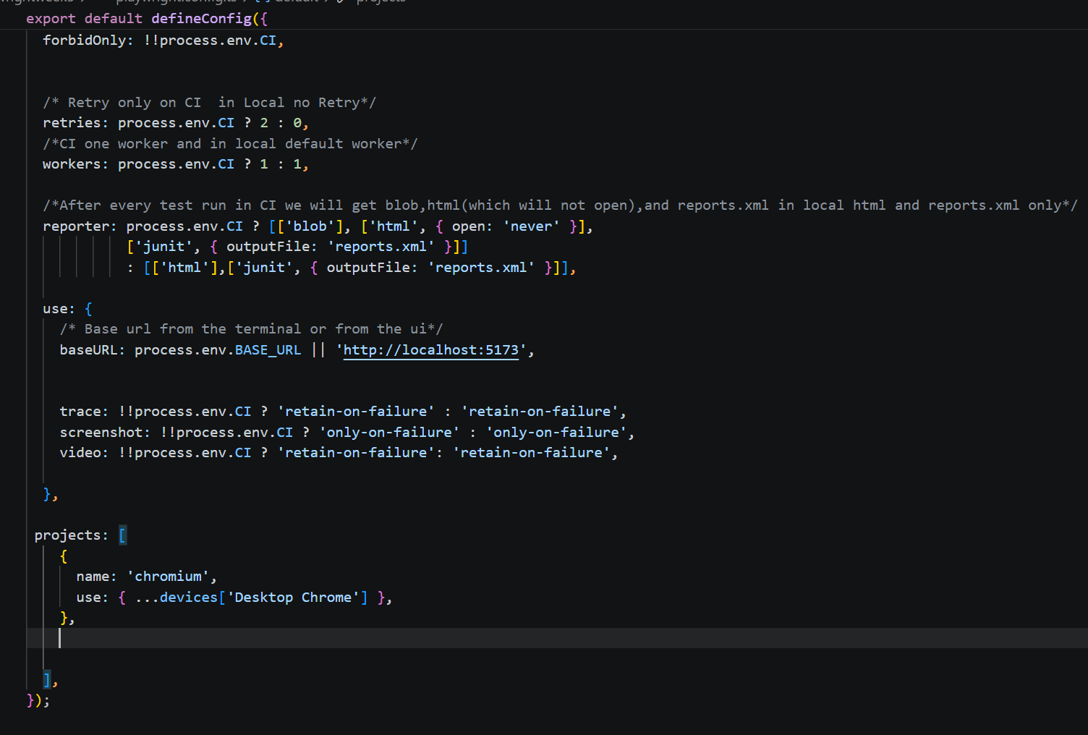

Conclusion:
Test are passing sucessfully

